**Computer Vision**

**Hand Book**

**Disclaimer: The content is curated from online/offline resources and used for educational purpose only**

# Premium Vector | White abstract background in 3d paper style | Abstract backgrounds, Abstract, Geometric backgroundTable of Contents

Table of Contents i

Learning Outcomes iii

Chapter 6: Introduction to Image Processing 4

6.1 Introduction 4

6.2 Applications of Image Processing with Green Technology and Sustainability 32

References 36

Chapter 6: Introduction to Image Processing

|  |
| --- |
| **Learning Outcomes:**  By the end of this chapter, students will be able to:   * Understand the concept and basics of digital images, pixels, color models, and image types. * Define and interpret resolution, size, and aspect ratio in images. * Apply smoothing and sharpening to enhance image clarity. * Use thresholding methods to segment and interpret images. * Define image and explore OpenCV for basic image processing tasks. * Train and use image models with Google’s Teachable Machine. * Identify sustainable applications of image processing in green tech. |

## 

## 6.1. What is Image Processing?

Image processing is the use of algorithms and techniques to analyze, manipulate, and enhance digital images. It plays a significant role in various applications, including medical imaging, security, and manufacturing. When applied to sustainability, image processing can support environmental monitoring, optimize natural resource management, and promote more sustainable practices across industries.

Image processing typically involves several stages, including:

* Image Acquisition: Capturing images using cameras or sensors.
* Preprocessing: Preparing images by reducing noise, adjusting brightness, or enhancing clarity.
* Segmentation: Dividing an image into meaningful regions, such as different plant types or areas of a city.
* Feature Extraction: Identifying specific features, like patterns or shapes, within an image.
* Classification and Analysis: Using machine learning models to categorize or analyze these features for specific applications

Image processing is a crucial technology in the journey towards sustainability. From tracking air quality to optimizing agriculture and managing urban resources, it allows for a more informed and proactive approach to environmental and resource management. While challenges remain, ongoing innovations in AI, green technology, and computational efficiency are paving the way for even greater contributions of image processing to a sustainable future.

## 6.1.8 OpenCV (Open Source Computer Vision Library)

OpenCV (Open Source Computer Vision Library) is the comprehensive library primarily developed for real-time computer vision and image processing. It originated from Intel in 1999 and with significant contributions and support, is today maintained by the OpenCV Foundation. It is free to use under an open source license, in both academic and commercial applications, under the Apache License 2.0.

Main Features

* Large Collection of Algorithms: Over 2,500 optimized algorithms, with applications in facial recognition, object detection, motion tracking, and image stitching
* Compatibility: Works on various operating systems such as windows, Linux, macOS, Android, and iOS.
* Support: Written mainly in C++ with interfaces to Python, Java, MATLAB/Octave, and more.

Applications

Many use it across different fields because of the strong capability of OpenCV.

* Facial Recognition: Identify and verify faces in images and videos.
* Gesture Recognition: Interpretation of human gestures using computer vision.
* Augmented Reality (AR): Overlying digital information on the real world.
* Mobile Robotics: Assistance of robots in navigating and object manipulation.

**Installation of OpenCV on Windows via pip**

OpenCV computer vision open source library has gained predominant usage in machine learning and processing image purposes. OpenCV operates in diverse functions like object detection and recognition, facial recognition, motion tracking among others. Here is how you can install OpenCV on your desktop Windows.

Requirements   
First, you need to check if you already have Python and pip set up in your system. Python is the programming language where these scripts were written, while pip is a package manager that makes software packages very easy to install in Python.

You can check if Python has been installed or not. To do this, open Command Prompt and then

python –version

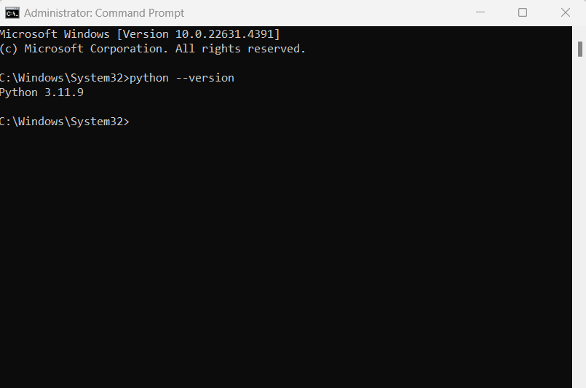

If Python is installed, you should be able to see the version number that appears there. If not, you'll need to install Python.

To check if pip has been installed, type the following command to see if you get any output:

pip –version

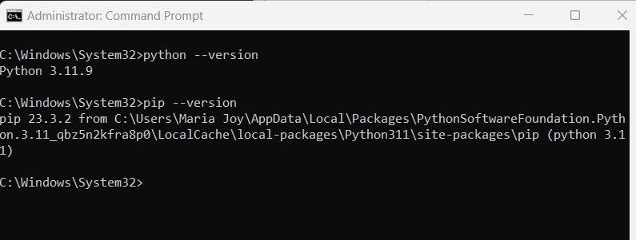

If pip is not installed, then you'll need to install it first. You can often find pip by reinstalling Python and then clicking "Add Python to PATH" in the setup options.

**Step-by-Step Installation Instructions**

Step 1: Access Command Prompt

Win + R, type cmd, and then press Enter. This opens the Command Prompt where you will put the installation commands.

Step 2: Update pip

It is also a good habit to keep pip updated. You can update pip by typing the following command in the terminal:

pip install --upgrade pip

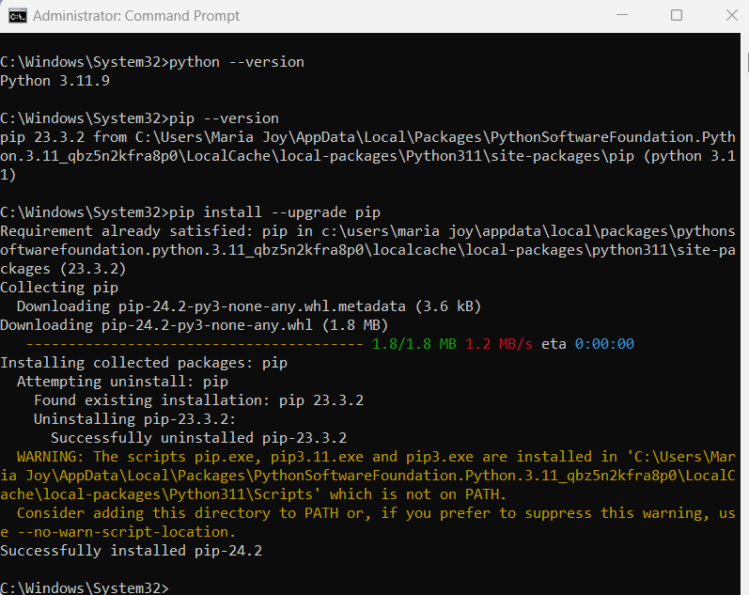

Step 3: Installation of OpenCV

You are ready to download OpenCV. In order to install the main package of OpenCV, you can simply enter the following command in the terminal:

pip install opencv-python

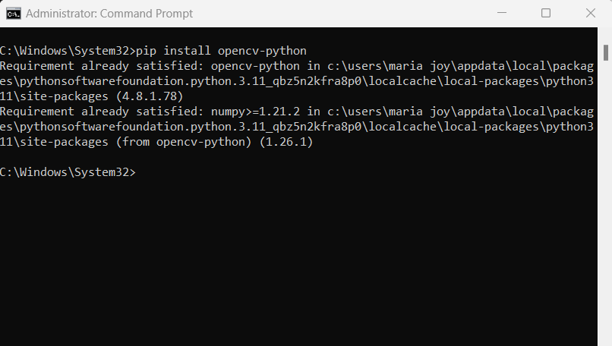

If you need some extra functionalities, you can use:

pip install opencv-contrib-python

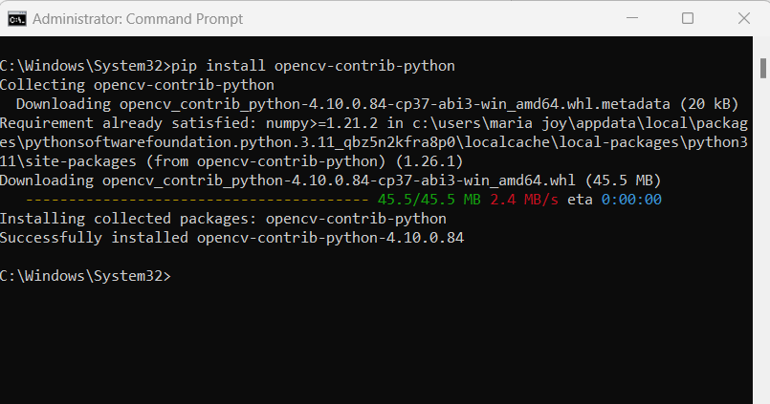

Wait for installation - it takes sometimes even up to a couple of minutes, depending on your connection and system performance.

Step 4: Verify Installation

Open the Python environment in your command prompt and type in python, and then enter this statement:

import cv2

print(cv2.__version__)



If you did everything correctly, it should display the version installed.

Here's an example in Python using image processing with OpenCV and scikit-image libraries to analyze vegetation health in agricultural fields. This type of analysis can help in sustainable agriculture by identifying unhealthy crop areas early, which reduces the need for excessive pesticide and water use.

The example uses a vegetation index called NDVI (Normalized Difference Vegetation Index), which is widely used in remote sensing to analyze the health of vegetation. NDVI values range from -1 to +1, where higher values indicate healthier vegetation.

**Using Python for Vegetation Health Detection**

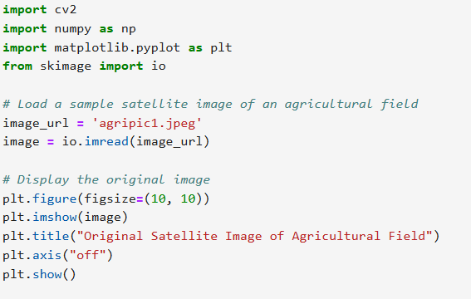

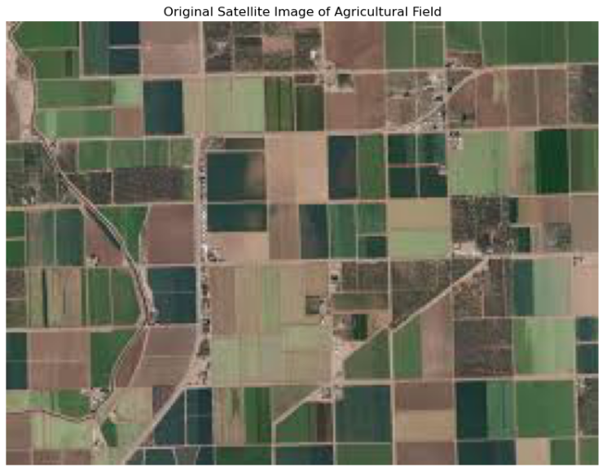

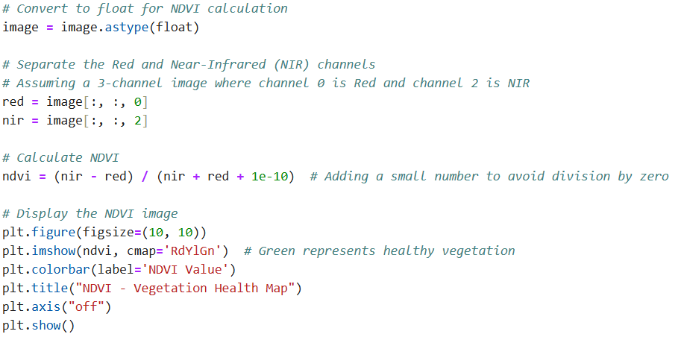

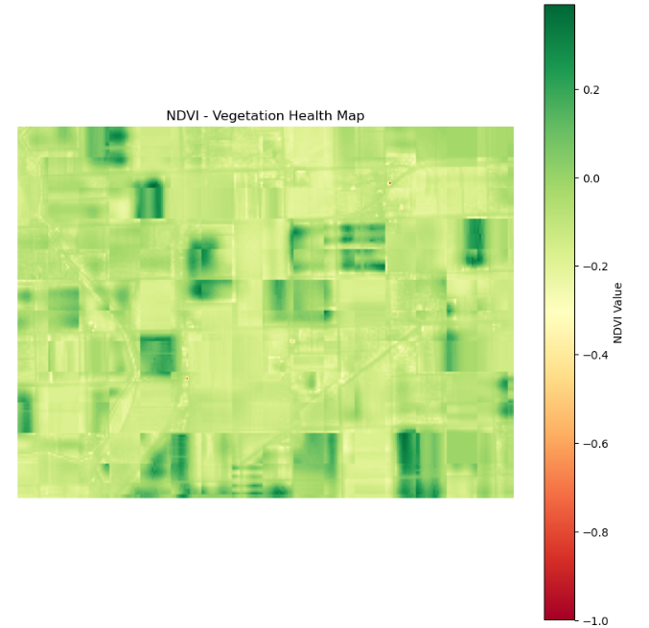

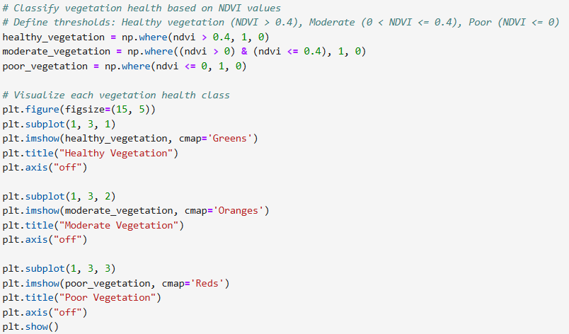

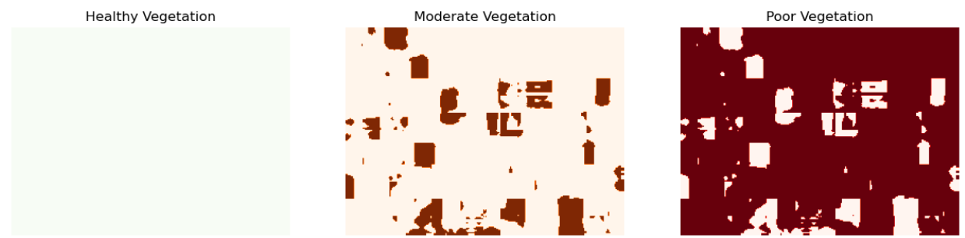

**Image Loading**

 We load an agricultural satellite image using skimage.io.imread. This image should ideally be in a format where it has near-infrared (NIR) and red channels, typically used in NDVI calculations.

Visualization

* We visualize the NDVI values using plt.imshow with the RdYlGn colormap (where green indicates higher NDVI values).
* We create binary masks for healthy, moderate, and poor vegetation based on NDVI thresholds.

Health Classification

* Using thresholds, we classify vegetation health: "Healthy" (NDVI > 0.4), "Moderate" (0 < NDVI ≤ 0.4), and "Poor" (NDVI ≤ 0).
* Separate plots are generated to show each class.

**Sustainable Benefits of This Analysis**

Using NDVI and similar vegetation indices helps farmers monitor crop health and respond proactively to areas showing stress. By targeting only the unhealthy areas for intervention (e.g., adding water or fertilizer), this approach promotes resource efficiency and reduces waste. This contributes to sustainable agriculture by minimizing environmental impact while maintaining productivity.

This example provides a powerful way to promote sustainability in agriculture using image processing in Python. The process can be expanded for larger, automated applications in agriculture monitoring systems, making it invaluable for sustainable resource management.

## 6.1.9 Image Processing using teachable machine

Teachable Machine for image processing in sustainability projects is an excellent approach for quick prototyping without needing advanced coding. Teachable Machine is a web-based tool that allows you to train machine learning models for image, sound, and pose classification using your browser.

**How Teachable Machine Works for Image Processing**

Teachable Machine uses a straightforward process where users can train a model on their own labeled image dataset. The process involves three primary steps:

* Data Collection and Labeling: Users upload images for each class they want the model to recognize. For sustainability, these could be images of various recyclable materials (like plastics, glass, and metals), different plant species, or signs of pollution in natural landscapes. Each category is labeled accordingly, allowing the model to distinguish between them.
* Model Training: Teachable Machine employs deep learning algorithms that train on the labeled images. Training involves multiple passes over the images to recognize patterns and features unique to each class. Teachable Machine makes this complex process easy to follow, with a training progress indicator and a test phase.
* Export and Deployment: After training, the model can be exported as a TensorFlow or JavaScript model. This flexibility allows integration into web or mobile applications, making it highly versatile. Models can be run locally, which is important for privacy and low-energy deployment—key sustainability factors for reducing the carbon footprint associated with large-scale cloud processing.

**Collect or Capture Images**

For any project, you’ll need images for each class you want to detect. Collect or capture these images, ensuring a variety of backgrounds, angles, and lighting conditions to help the model generalize better. Aim for at least 30 images per class.

**Train the Model Using Teachable Machine**

1. Open Teachable Machine: Go to Teachable Machine.
2. Create a New Project: Choose “Image Project” to start.
3. Add Classes: For instance, for a waste-sorting project, add classes like “Plastic,” “Metal,” “Paper,” and “Organic.”
4. Upload Images: Upload the images collected for each class into their respective categories.
5. Train the Model: Click “Train Model” to begin the training process. Teachable Machine will handle the rest, using transfer learning to speed up the training.

**Test and Export the Model**

* Test Model: After training, test it directly within Teachable Machine to see how well it recognizes the images.
* Export the Model: Once satisfied, export the model for use. Teachable Machine provides options to download as TensorFlow.js, TensorFlow Lite, or for other formats, which can be integrated into web or mobile applications.

**Integrate into an Application**

Use your exported model in a simple web or mobile application. For example, a web app can use TensorFlow.js to classify images from a live camera feed, ideal for a recycling bin setup where users can check the category of waste in real-time.

Example,

Let's go through a practical example of using Teachable Machine to create an image classification model for waste sorting to help improve recycling efforts. This will walk through the setup, training, and potential deployment of a model that can distinguish between types of waste, such as plastic, paper, glass, and organic materials.

**Preparing the Dataset**

The first step is to gather images for each waste category. You’ll need a variety of images representing each type to account for differences in lighting, angles, and backgrounds. For example:

* **Plastic**: Bottles, plastic bags, packaging materials
* (https://www.kaggle.com/datasets/siddharthkumarsah/plastic-bottles-image-dataset)

For a simple project, around 20-50 images per category is a good start. You can capture these images yourself, or download sample images from free online sources.

**Training the Model with Teachable Machine**

1. **Open Teachable Machine**:

* Go to Teachable Machine.
* (https://teachablemachine.withgoogle.com/)
* Choose the **Image Project** option and then **Standard Image Model**.

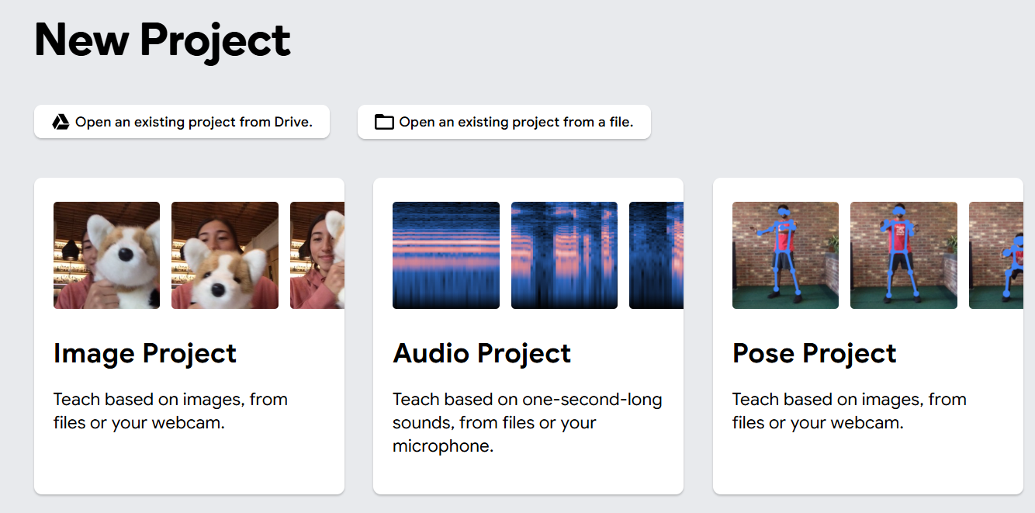



1. **Set Up Classes**:

* By default, Teachable Machine gives you a class labeled “Class 1.” Rename it to “Plastic.”
* If required, Click **Add a Class** for each waste type, and rename them as “Paper,” “Glass,” and “Organic Waste.”

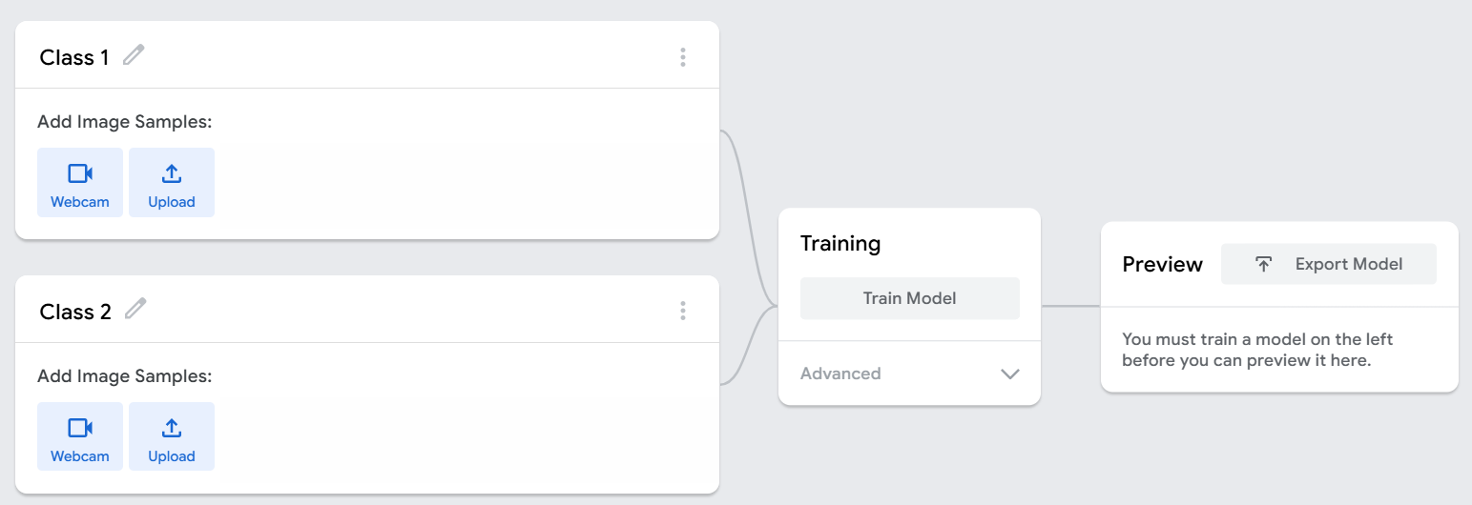

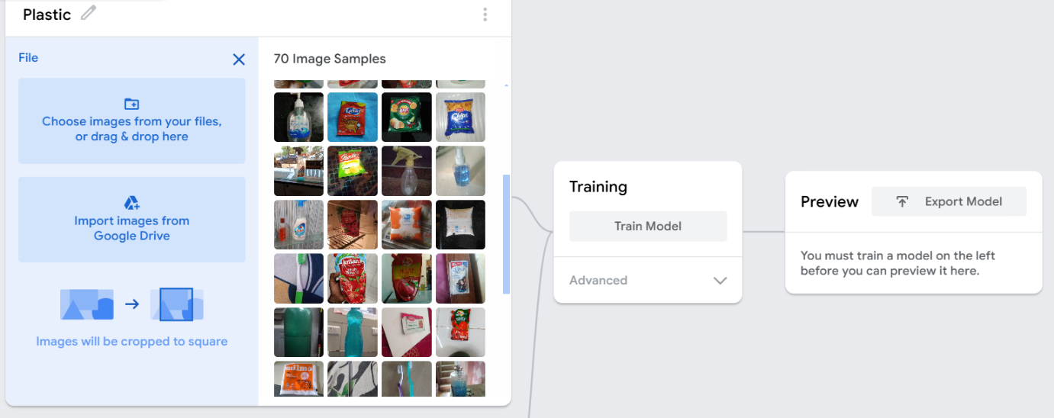

1. **Upload Images**:

* For each class, upload your prepared images.
* Make sure each waste type has enough examples for the model to learn distinct features. The more images, the better the model’s performance.

1. **Train the Model**:

* Once images are uploaded and categorized, click on the **Train Model** button.



* Teachable Machine will process the images, building a model that recognizes patterns in each category.

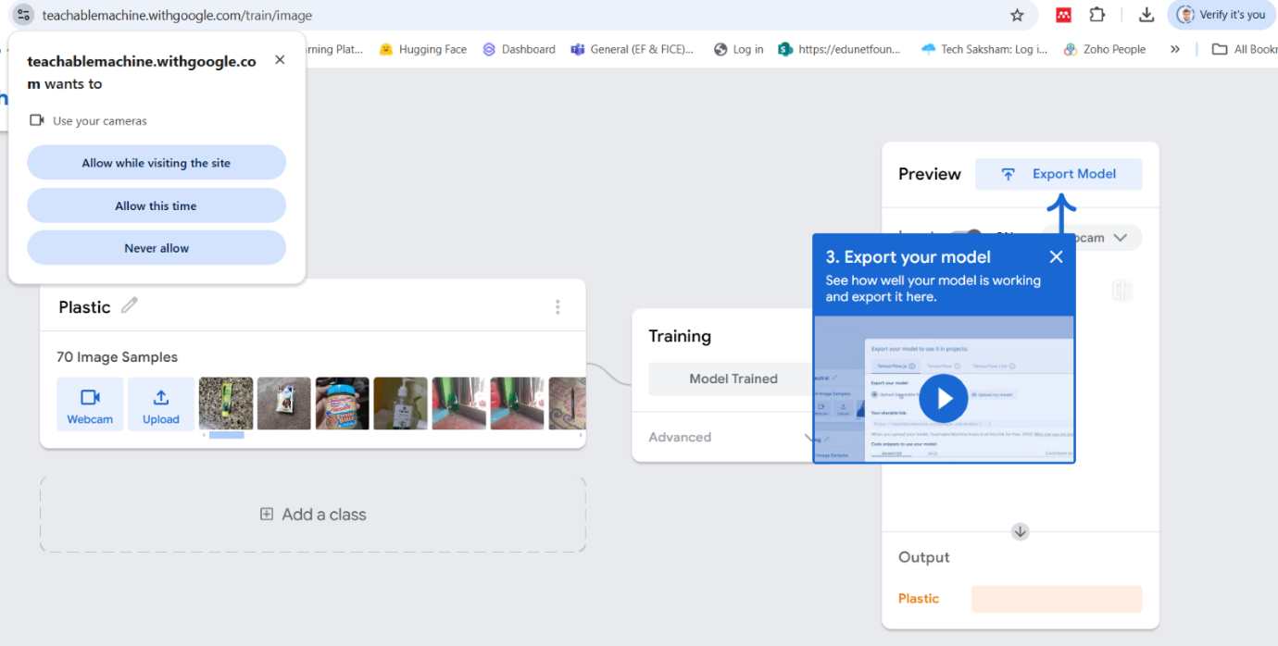

1. **Testing the Model**:

* After training, test the model by uploading or using the webcam to capture new images of each waste type.

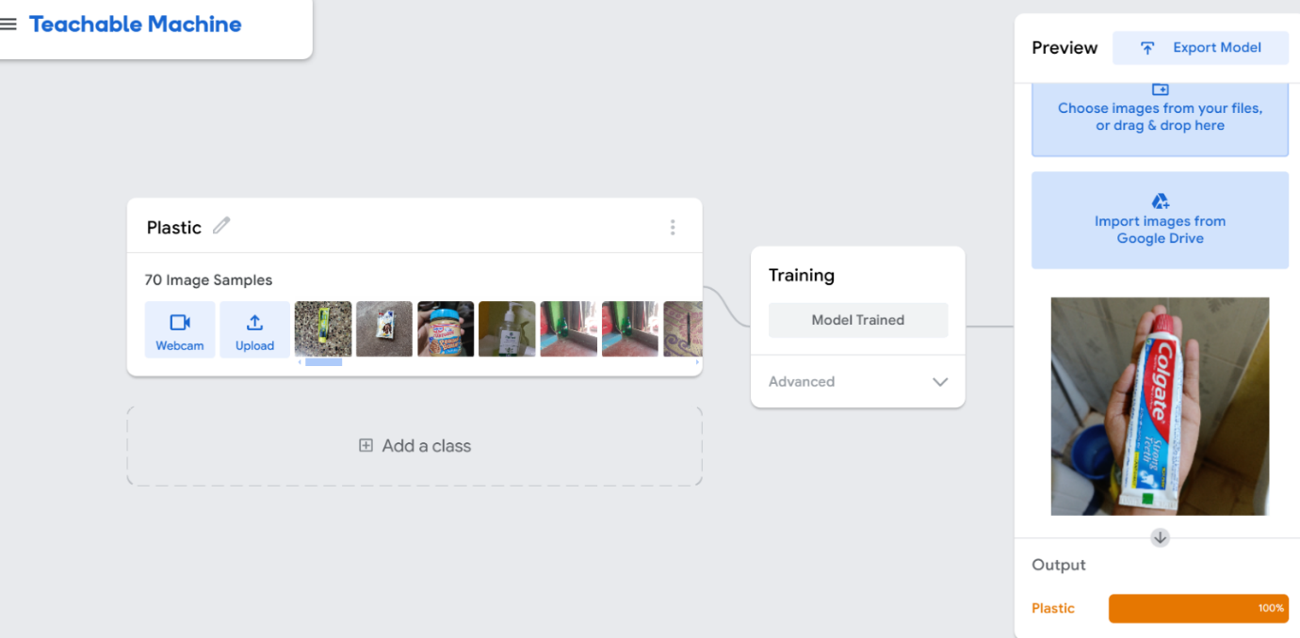

* The model will display predictions, showing the likelihood that an image belongs to each category.

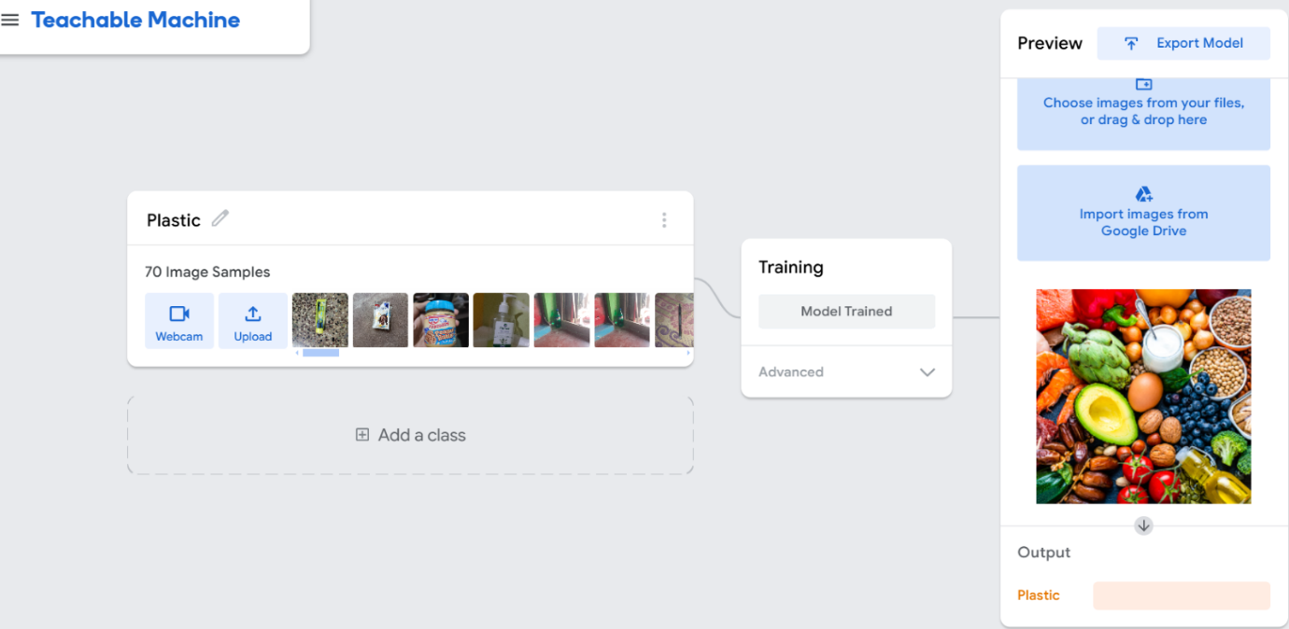

# 6.2 Applications of Image Processing with Green Technology and Sustainability

Image processing plays a vital role in green technology and sustainability, enabling innovations in agriculture, environmental conservation, renewable energy, and waste management. By utilizing image analysis, pattern recognition, and machine learning, image processing helps detect, monitor, and manage resources in an eco-friendly way. Here are some prominent applications that contribute to sustainability:

## 6.2.1 Precision Agriculture

* Crop Monitoring: Image processing helps monitor crop health and detect diseases early through satellite or drone images. Techniques like the Normalized Difference Vegetation Index (NDVI) allow farmers to assess plant health by analyzing chlorophyll content and stress levels.
* Water and Fertilizer Management: Image processing enables efficient water and nutrient distribution based on soil and crop conditions, minimizing excess use and promoting sustainable resource management.
* Yield Prediction: By analyzing past and present crop images, farmers can predict yields more accurately. This helps in planning and prevents overuse of fertilizers and pesticides, which reduces environmental impact.

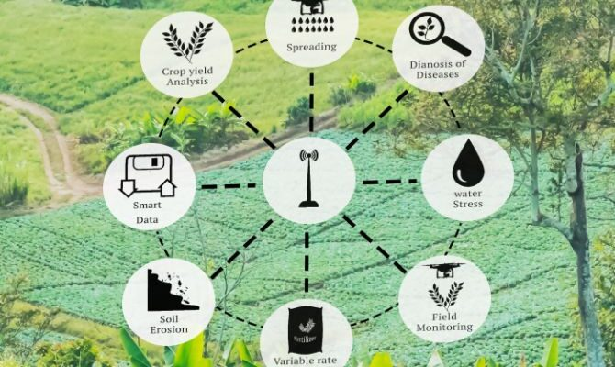

Source: <https://agriculturepost.com/opinion/technology-adoption-is-key-to-sustainable-regenerative-farming/>

## 6.2.2 Forest and Wildlife Conservation

* Deforestation Monitoring: Satellite and aerial images processed with machine learning can track deforestation and changes in forest cover over time. This real-time monitoring helps conservationists identify illegal logging activities and take timely actions.
* Wildlife Tracking: Wildlife populations can be monitored through drones or camera traps, providing insights into species distributions, population dynamics, and behavior. This data is crucial for protecting endangered species and preserving biodiversity.

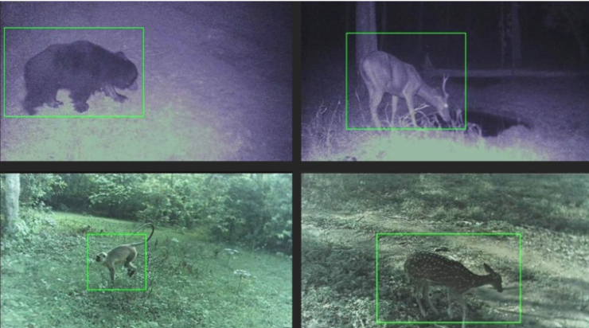

Source: <https://www.natural-solutions.world/blog/wildlife-conservation-artificial-intelligence-for-camera-trapping-1>

* Forest Health Assessment: Image processing can detect forest diseases or stress conditions due to droughts or pests, enabling preventive measures and more sustainable forest management.

## 6.2.3 Waste Management and Recycling

* Waste Sorting: Advanced image recognition systems classify waste materials (like plastics, metals, and glass) on recycling conveyor belts, reducing contamination and improving recycling efficiency.

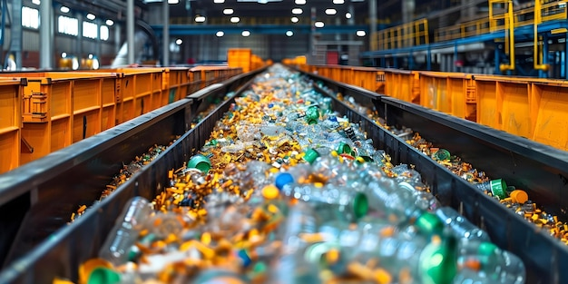

Source: <https://www.freepik.com/premium-ai-image/recycling-line-waste-sorting-plant-concept-waste-sorting-plant-recycling-process-sorting-line-environmental-impact-waste-management_252583248.htm>

* Landfill Monitoring: Drones capture images of landfills to monitor waste accumulation, methane emissions, and leachate management. This enables better control of pollutants and reduces the environmental impact of waste disposal.
* E-Waste Management: Image processing helps separate electronic waste components for recycling by identifying recyclable parts. Efficient e-waste management reduces hazardous waste and supports sustainable material recovery.

## 6.2.4 Climate Change and Environmental Research

* Glacier Monitoring: Image analysis of glaciers over time provides data on glacier melting rates and sea-level rise, helping scientists track climate change impacts.
* Climate Modeling: Historical images of ecosystems, weather patterns, and ocean conditions provide data for climate models, which aid in predicting future environmental changes and planning mitigation strategies.
* Ecosystem Health Assessment: Satellite and aerial imagery track ecosystem health by assessing plant and soil conditions, biodiversity levels, and water availability. These insights help in ecosystem conservation and sustainable resource management.

## 6.2.5 Air and Water Quality Monitoring

* Air Quality Assessment: Image analysis of urban areas can monitor pollutants and estimate air quality. Remote sensing with satellite images allows for tracking pollutants like CO₂ and particulate matter, which helps in assessing urban environmental health.
* Water Quality Monitoring: Using images from satellites or underwater cameras, authorities can track algae growth, water turbidity, and contamination levels. By detecting pollutants in real-time, authorities can take action to protect water bodies and ensure safe water resources.
* Plastic Detection in Oceans: Image processing techniques help identify plastic waste patches in oceans. Using high-resolution images, organizations can monitor plastic accumulation in water bodies and develop targeted cleanup strategies.

## 6.2.6 Renewable Energy Management

* Solar Panel Inspection: Drones equipped with thermal cameras can capture images of solar panels to detect defects and inefficiencies. This analysis helps maintain optimal performance and prolongs the life of solar panels, contributing to sustainable energy production.
* Wind Turbine Maintenance: Image processing with drones allows for efficient monitoring of wind turbines, identifying wear and tear on blades or other structural issues. This preventive maintenance approach reduces downtime and ensures steady, clean energy generation.
* Site Selection for Renewable Installations: Geographic image analysis can identify ideal locations for wind and solar farms based on environmental factors like sunlight exposure, wind patterns, and terrain. This ensures that renewable installations are placed optimally, maximizing energy production with minimal environmental impact.

## 6.2.7 Urban Sustainability and Smart Cities

* Urban Green Space Management: Using aerial images, city planners can monitor green spaces, calculate vegetation coverage, and promote sustainable landscaping in urban environments.
* Traffic and Pollution Control: Image processing can analyze vehicle movement, reduce congestion, and limit pollution through optimized traffic flow and emission monitoring.
* Infrastructure Maintenance: High-resolution images and computer vision systems are used to assess infrastructure like roads, bridges, and buildings for wear and tear. This predictive maintenance reduces resource consumption and promotes sustainability.

## 6.2.8 Disaster Management and Recovery

* Early Warning Systems: Image processing with satellite data helps in monitoring natural disasters like floods, landslides, and wildfires. Real-time monitoring enables rapid responses and minimizes damage.
* Post-Disaster Assessment: Images taken before and after a disaster can analyze damage extent and identify areas needing immediate assistance. This analysis aids in efficient resource allocation for recovery efforts.
* Erosion Control: By analyzing shoreline and land images, authorities can monitor erosion patterns, implement control measures, and prevent land loss, preserving natural habitats.

# References

1. <https://www.weforum.org/agenda/2024/02/green-jobs-green-skills-growth/>
2. <https://digital-photography-school.com/understand-pixels-resolution-resize-photoshop/>
3. <https://www.adobe.com/uk/creativecloud/photography/discover/image-resolution.html>
4. <https://www.javatpoint.com/difference-between-rgb-and-cmyk>
5. <https://www.javatpoint.com/dip-types-of-images>
6. <https://www.techtarget.com/whatis/definition/resolution>
7. <https://www.geeksforgeeks.org/image-enhancement-techniques-using-opencv-python/>
8. <https://www.scaler.com/topics/thresholding-in-image-processing/>
9. <https://www.geeksforgeeks.org/image-classification-using-googles-teachable-machine/>
10. <https://accedia.com/insights/blog/10-business-applications-of-image-processing-and-recognition-technology>
11. <https://www.ijraset.com/research-paper/green-path-project-develops-using-image-processing>

**Disclaimer: The content is curated from online/offline resources and used for educational purpose only**